**Exercise 9: Online Bookstore - Understanding HATEOAS**

**Business Scenario:**  
Enhance your REST API to follow HATEOAS (Hypermedia as the Engine of Application State) principles for navigation through resources.

**HATEOAS** stands for **Hypertext Application Transfer Protocol Engine**, and it's a key architectural constraint in RESTful APIs. It essentially means that the API should provide enough information in the response to allow clients to discover how to interact with the API without needing prior knowledge of the API's structure.

In simpler terms, the API should include links and other metadata in its responses that tell clients what actions they can take and where to go next. This makes the API more flexible and easier to use, as clients don't need to be hardcoded with specific API endpoints or request formats.

**Instructions:**

1. **Add Links to Resources:**
   * Use Spring HATEOAS to add navigational links to the resources in your API responses.
2. **Hypermedia-Driven APIs:**
   * Build hypermedia-driven APIs by providing links to related resources and actions that a client can follow, making the API self-descriptive and enabling better API navigation and discoverability.

**Implementation Documentation:**

**1. Adding Links to Resources:**

To implement HATEOAS in API, Spring HATEOAS is used. This involves adding self-referential and related links to each resource representation. In the BookController, links to each book and a collection of books were added using WebMvcLinkBuilder:

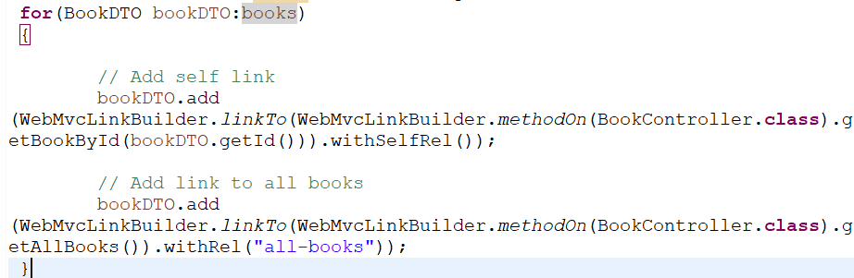 The withSelfRel() method defines the link as a self-referential link, while withRel("all-books") defines a link to a collection of all books.

**2. Hypermedia-Driven APIs:**

By enhancing API to follow HATEOAS principles, the API guides clients through the available actions, reducing client-side complexity.

For example, when a client fetches a list of books, each book now includes:

* A self link (self) to retrieve that specific book.
* A related link (all-books) to fetch all books.

This way, clients can discover further actions (like retrieving all books or fetching a specific book by its ID) through the provided links.

First Adding and then Retrieving All Books:

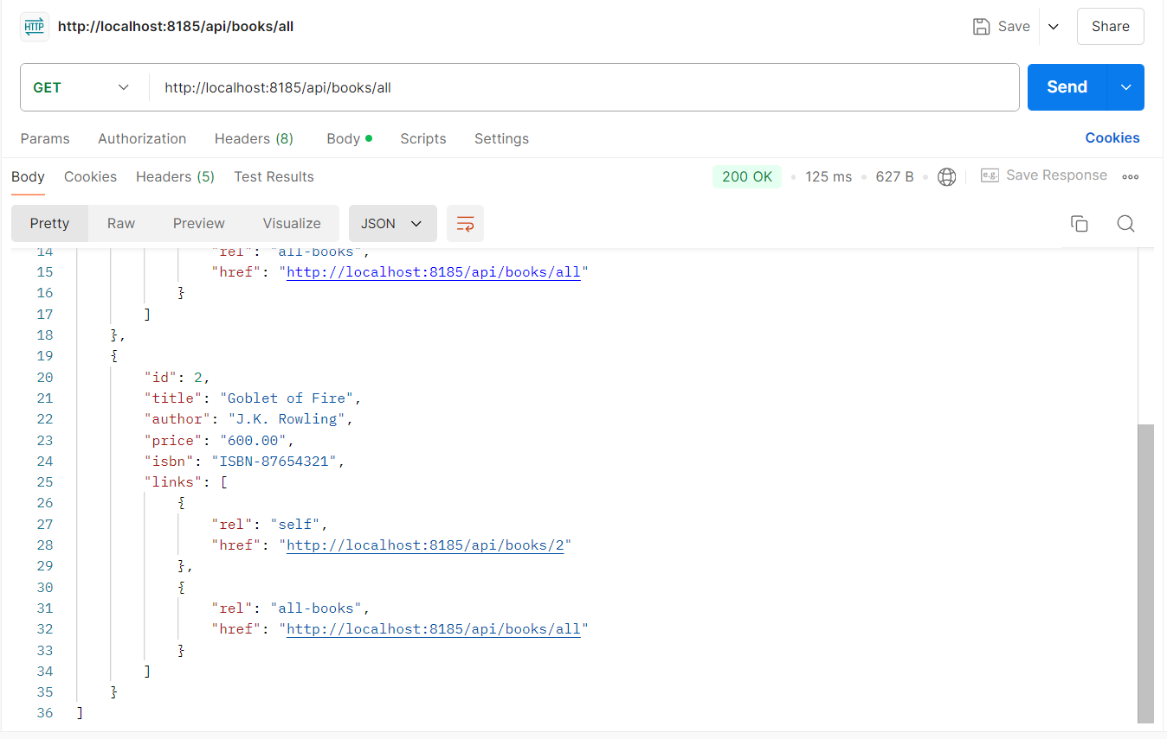

Clicking on the first link of Book 1:  
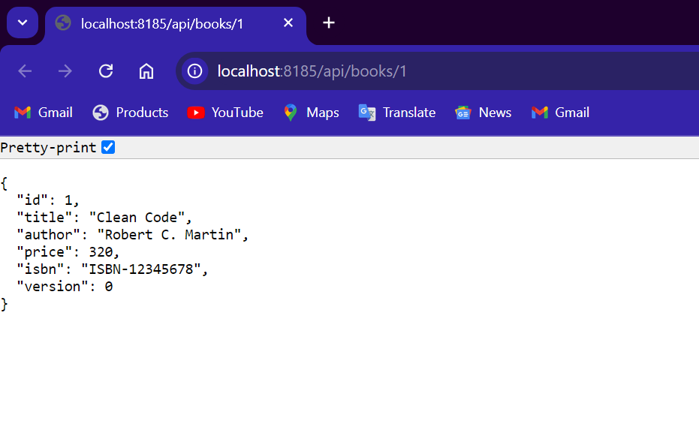

Clicking on the second link of Book 2:

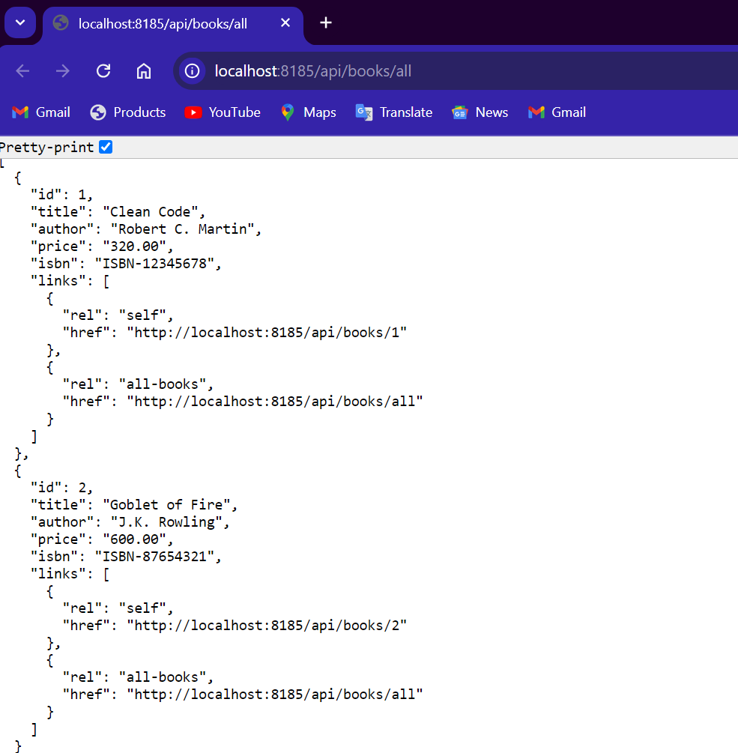

**Summary:**

By integrating Spring HATEOAS into your application, API becomes more robust and self-documenting, providing clients with navigational hints about how to use API effectively.